<https://seekingalpha.com/news/3587959-adps-wild-revision-throws-market-curveball>

ADP's wild revision throws market a curveball

Jul. 1, 2020 3:13 PM ET|By: Kim Khan, SA News Editor

The headline number of ADP’s measure of June private-sector jobs, up 2.4M, was below forecasts but not particularly market-moving. It showed a decent increase, not far off the 3M predicted for government payroll numbers tomorrow.

But May’s revision of up 5.8M, going from the initial report of 2.8M jobs lost to 3M gained, revved up S&P futures. Such a revision would’ve been further confirmation that economists had gauged May completely wrong (consensus for official nonfarm payrolls was for a drop of 8M last month).

Only it turned out the revision wasn’t quite what it seemed.

Moody’s Analytics Chief Economist Mark Zandi, who works with ADP on the report, explained the huge revision was the result of benchmarking the data series to official BLS numbers.

“There is no information in that revision,” Zandi told CNBC. “It is simply the result of the fact that our objective here is to predict the BLS number with the ADP data and to do that as accurately as possible."

That took investors, who are used to revisions providing more accurate and granular numbers than the first estimate, by surprise. The broader market gave back some early gains once the ADP clarification hit the wires.

ADP numbers, like API oil inventory data, are well-known for their dislocation to the government figures. For ADP, those dislocations are smoothed out, as you can see from the first chart comparing the two datasets. In the chart, ADP tracks BLS almost exactly (on revised numbers), just at a lower total payrolls number as it tracks only private employment.

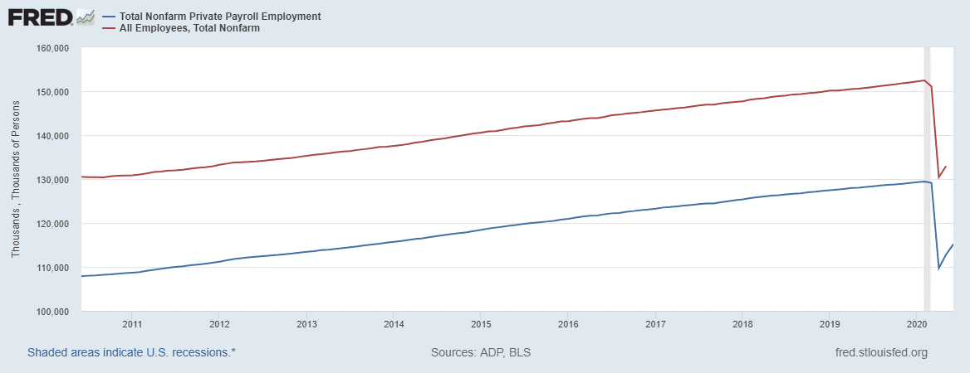

Figure - ADP Payrolls (Blue) vs. BLS Payrolls (Red)

Maybe nobody has paid much attention to ADP revisions until now, where the numbers are so much bigger. The chart below shows the difference between the change in payrolls reported by ADP and the BLS figures (BLS – ADP), which illustrates the May revision's attempt to narrow the gap.

And the ADP hasn’t revised a negative reading to a positive reading since its report on August 2010 jobs (and that was just from -10K to +10K).

So, if there's a surprise drop in June nonfarm payrolls tomorrow, watch for another big ADP revision next month.

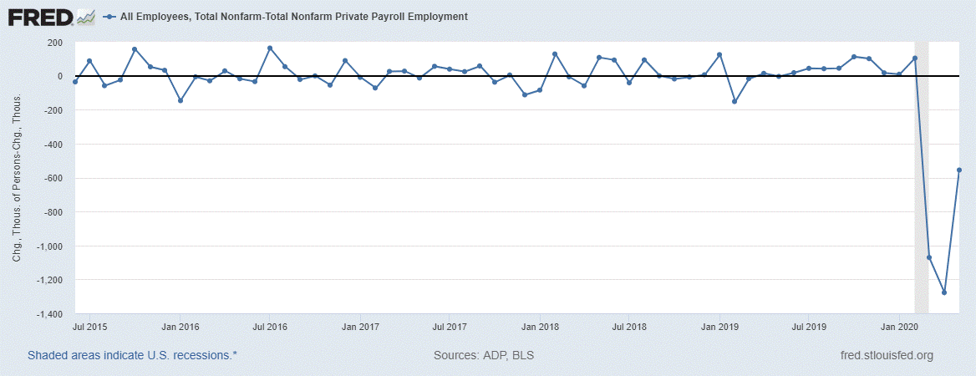

Figure - BLS Payrolls Change - ADP Payrolls Change (Monthly)